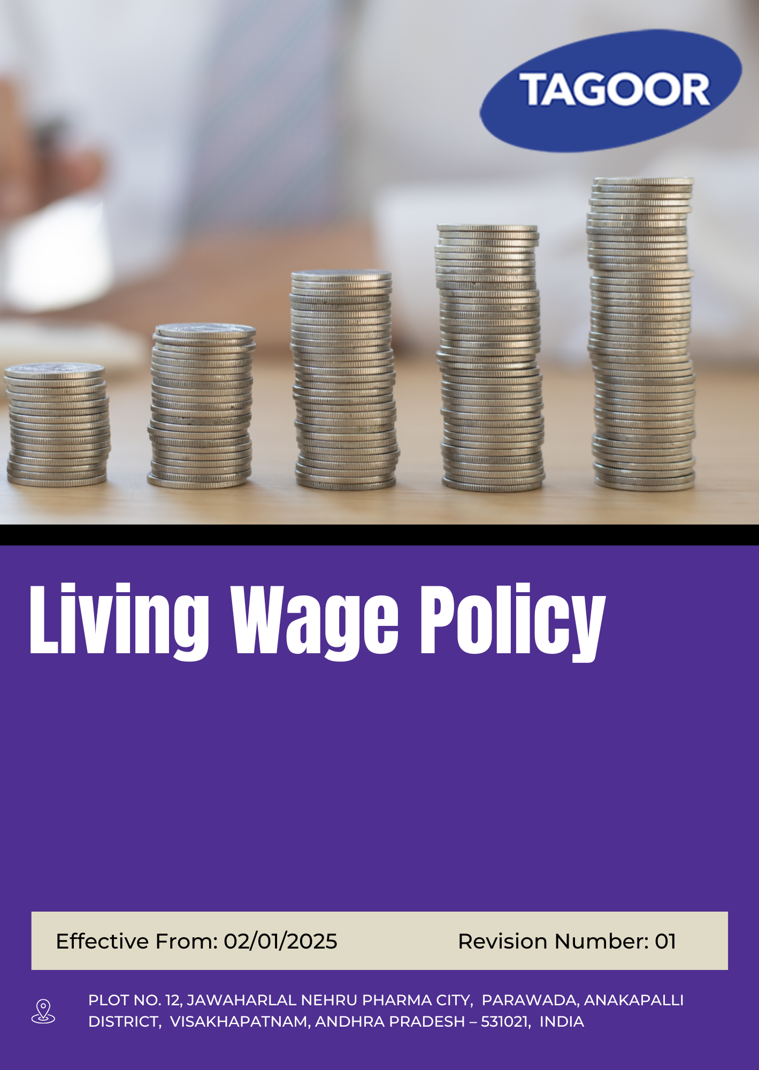
INDEX
1. About this Policy 3
2. Scope & Applicability 3
3. Tagoor’s Vision and Approach for Fair Wages 3
4. Tagoor’s Fair Wages Objectives 4
5. Tagoor’s Approach for Establishing a Living Wage 4
6. Organizational Responsibilities 5
7. Tagoor’s Fair Compensation Performance Targets 6
8. Tagoor’s key strategies for Fair Compensation 7
9. Covered Sustainable Development Goals (SDGs) 8
10. Monitoring and Reporting of Fair Compensation Practices Performance 8
11. Review Mechanism 9
12. Employee Acknowledgement & Commitment Declaration 10

About this Policy
This Fair Wage Policy (“Policy”) is established by Tagoor Laboratories Pvt. Ltd. (“the Company”) to ensure fair, equitable, and lawful compensation practices across all its operations and workforce.

The Company is committed to integrating fair wage principles into its human resource management systems, payroll processes, and overall employment practices. This Policy outlines the Company’s objectives, key focus areas—including minimum wage compliance, equal pay for equal work, wage transparency, and timely payment—and the mechanisms for monitoring, evaluation, and continuous improvement.

The Company has adopted appropriate systems, controls, and procedures to ensure compliance with applicable labour laws and statutory wage requirements and to promote a culture of fairness, equity, and respect for workers’ rights across all levels of the organization.

Scope & Applicability
This Fair Wage Policy (“Policy”) applies to all operations, activities, and facilities of Tagoor Laboratories Pvt. Ltd. (“the Company”). It is applicable to all employees at all levels, as well as contractors, suppliers, service providers, business partners, and any other individuals or entities working on behalf of the Company.
Company | Registered Address
Tagoor Laboratories Pvt Ltd | Plot No. 12, Jawaharlal Nehru Pharma City, Parawada, Anakapalli District, Visakhapatnam, Andhra Pradesh – 531021, India.

Tagoor’s Vision and Approach for Fair Wages

The Company has adopted a structured approach to fair wage management based on the following principles:
- Prevent: Wage-related risks such as non-compliance, wage discrimination, delays in payment, and inequitable compensation shall be identified, assessed, and controlled through appropriate systems and procedures at all stages of employment and payroll management.
- Comply: The Company shall comply with all applicable labour laws, minimum wage regulations, statutory requirements, and industry standards related to compensation, benefits, and working conditions.
- Improve: The Company shall strive for continuous improvement in wage fairness and transparency through regular reviews, benchmarking, audits, and implementation of corrective actions where required.

Tagoor’s Fair Wages Objectives
- To ensure that all employees receive fair wages that meet or exceed applicable statutory requirements and support basic living needs.
- To promote equitable, transparent, and consistent wage practices across all levels of the organization.
- To support employee well-being, dignity, and financial stability through responsible compensation practices.
- To ensure compliance with applicable labour laws, wage regulations, and statutory requirements.
- To prevent unfair wage practices, including delayed payments, unauthorized deductions, and wage discrimination.
- To promote equal opportunity and non-discriminatory compensation practices, including equal pay for equal work.
- To strengthen transparency, accountability, and accuracy in payroll and wage administration processes.
- To encourage continuous improvement in wage practices through periodic review and alignment with economic conditions and industry standards.

Tagoor’s Approach for Establishing a Living Wage
Tagoor Laboratories Pvt Ltd adopts a structured and transparent approach to determine living wage levels to ensure employees receive remuneration that supports a decent standard of living.

- Legal Compliance: Wages are first aligned with all applicable statutory minimum wage laws and labor regulations in the respective operating locations.
- Benchmarking Approach: Living wage levels are assessed using credible external references such as government wage data, recognized wage studies, and relevant regional or international living wage benchmarks.
- Cost of Living Consideration: Wage adequacy is evaluated based on essential living costs, including food, housing, healthcare, education, transportation, and other basic household needs.
- Geographical Context: Living wage determination considers regional variations in cost of living to ensure relevance to local economic conditions.
- Family Needs Perspective: Wage assessment considers the needs of employees and a reasonable number of dependents to support a basic but decent standard of living.
- Periodic Review: Living wage benchmarks are reviewed periodically to reflect inflation, economic changes, and updated benchmark data.
- Continuous Improvement: The Company is committed to progressively improving wage structures over time, in line with business sustainability and responsible business practices.

Organizational Responsibilities
The following roles and responsibilities apply across the organization:
Role | Designation | Key Responsibilities
Senior Management | Managing Director | Provide strategic oversight for implementation of living wage principles; ensure alignment with business objectives; allocate financial, technical, and human resources; promote a culture of fair wages, employee well-being, and financial dignity; oversee wage-related risk management; engage with stakeholders on responsible wage practices
Human Resources Department | HR Manager | Implement and monitor living wage practices; conduct wage benchmarking; ensure fair and consistent compensation structures; integrate living wage considerations into salary planning; communicate wage structure and benefits to employees
Finance and Payroll Department | Finance Manager | Ensure timely and accurate wage payments; support financial planning for living wage commitments; maintain transparent payroll systems; ensure statutory compliance; provide payroll data for benchmarking and analysis
Sustainability & Compliance Manager | Compliance Manager | Ensure compliance with labour laws and wage regulations; support alignment with living wage principles; monitor developments in wage standards; maintain documentation and reporting; drive continuous improvement in wage practices
Operations & Facilities Management | Plant Head | Ensure implementation of approved wage structures; support transparent communication of wage-related information; identify and escalate wage concerns; promote fair and equitable compensation practices; support employee awareness
Employee Representatives | Worker Representative | Facilitate communication on wage-related matters; promote awareness of living wage principles; collect employee feedback; support dialogue on fair compensation; build trust and transparency
Employees | All Staff | Adhere to compensation policies and procedures; participate in awareness initiatives; report wage-related concerns; support fair and transparent practices; engage responsibly in discussions on wages and benefits

Tagoor’s Fair Compensation Performance Targets

Focus Area | Target | Baseline Year | Target Year
Fair Wage Practices | Ensure 100% of employees receive wages equal to or above statutory minimum wages | 2023 | 2030
Fair Wage Practices | Maintain 100% of wage payments through documented and traceable payroll systems | 2023 | 2030
Fair Wage Practices | Ensure 100% timely wage payments as per defined payroll cycles | 2023 | 2030
Fair Wage Practices | Ensure 100% of wage deductions are authorized, documented, and traceable through transparent payroll processes, with 0 non-compliance cases identified during audits. | 2023 | 2030
Living Wage Consideration | Achieve at least 100% employee coverage under living wage benchmark assessment | 2023 | 2030
Living Wage Consideration | Improve wage adequacy index by at least 10% compared to baseline | 2023 | 2030
Living Wage Consideration | Integrate cost-of-living considerations into 100% compensation review processes | 2023 | 2030
Compliance with Labour Laws | Maintain 100% compliance with applicable wage-related labour laws | 2023 | 2030
Compliance with Labour Laws | Ensure 100% employee coverage under statutory benefits and wage provisions | 2023 | 2030
Continuous Improvement Targets | Achieve ≥95% employee awareness coverage on living wage policy through annual communication and training programs. | 2023 | 2030
Continuous Improvement Targets | Conduct 100% periodic wage structure reviews every year to ensure alignment with living wage benchmarks. | 2023 | 2030
Continuous Improvement Targets | Increase wage competitiveness index by minimum 5% year-on-year based on market and cost-of-living analysis. | 2023 | 2030

Tagoor’s key strategies for Fair Compensation
1. Fair Wage Practices
- Ensure fair, equitable, and transparent wage practices across all employees in alignment with statutory requirements and organizational standards.
- Strengthen payroll governance systems to ensure complete transparency, traceability, and accountability in wage processing.
- Foster a culture of timely and accurate wage disbursement as part of responsible employment practices.
- Promote zero-tolerance towards unauthorized or non-compliant wage deductions through robust internal controls and audit mechanisms.
2. Living Wage Consideration
- Integrate living wage principles into the organization’s compensation philosophy to ensure fair and adequate remuneration for all employees.
- Continuously strengthen wage adequacy by aligning compensation structures with recognized living wage benchmarks and socio-economic conditions.
- Embed cost-of-living considerations into compensation review processes to ensure sustainable and fair wage determination.
3. Compliance with Labour Laws
- Maintain strong adherence to all applicable labour laws related to wages, compensation, and employee benefits.
- Ensure full integration of statutory wage provisions and benefits into organizational HR and payroll systems.
- Promote a culture of legal compliance and ethical wage practices across all operational levels.
4. Continuous Improvement Targets
- Foster continuous awareness and understanding of living wage principles among employees through regular communication and engagement initiatives.
- Institutionalize periodic wage structure reviews to ensure ongoing alignment with living wage expectations and market conditions.
- Drive continuous improvement in wage competitiveness through benchmarking, market analysis, and progressive compensation enhancement strategies.

Covered Sustainable Development Goals (SDGs)
 |  |  |  | 

Monitoring and Reporting of Fair Compensation Practices Performance
At Tagoor Laboratories Pvt Ltd, structured monitoring and reporting systems are established to track fair wage and living wage performance and ensure transparency and continuous improvement.
- Monitoring: Key wage-related parameters (minimum wage compliance, living wage alignment, compensation equity, and payroll accuracy) are monitored against defined KPIs on a periodic basis. Results are compiled into performance dashboards for management review.
- Internal Audits: Payroll and wage compliance audits are conducted at least once a year across applicable functions. Audit findings are reported to senior management and corrective actions are tracked to closure.
- Management Review: Senior management reviews wage performance, benchmarking outcomes, audit findings, and progress against targets at defined intervals. Outputs from these reviews support compensation planning and policy improvements.
- Benchmarking Analysis: Wages are periodically benchmarked against regional living wage standards, industry practices, and cost-of-living indicators to ensure informed and fair compensation decisions.
- Non-Compliance Management: Wage-related discrepancies, including payroll errors or deviations from approved structures, are recorded, investigated, and addressed through defined corrective action mechanisms.
- Documentation & Data Integrity: Accurate, confidential, and auditable records of payroll, wage structures, and compensation reviews are maintained to ensure traceability and accountability.
- External Reporting: Wage and living wage performance is communicated through internal reporting systems and external disclosures, where applicable.

Review Mechanism
This Fair Wage Policy is subject to periodic review by the HR Manager at least once every two years, or earlier if required due to changes in labour laws, regulatory requirements, operational needs, or stakeholder feedback, to ensure its continued relevance, effectiveness, and alignment with evolving statutory obligations and organizational objectives.
The review process includes an assessment of wage compliance status, internal equity and fairness, benchmarking against industry standards, and feedback from relevant stakeholders. Based on this evaluation, necessary updates are incorporated to strengthen the policy framework and ensure alignment with applicable labour regulations, fair wage principles, and the Company’s commitment to equitable and responsible compensation practices.

Prepared By:

Approved By:

Last Review date: 01/01/2026

Next Review date: 01/01/2028

Employee Acknowledgement & Commitment Declaration
I, the undersigned employee of Tagoor Laboratories Pvt. Ltd., hereby acknowledge my understanding of the Company’s Fair Wage Policy and confirm the following commitments:
1. Awareness Confirmation
☐ I confirm that I have received the Fair Wage Policy
☐ I have read and understood its purpose, scope, and requirements
☐ I understand how it applies to my role and workplace activities
2. Commitment to Compliance
☐ I agree to comply with all applicable wage-related policies, procedures, and controls
☐ I will follow fair and transparent wage practices in all relevant activities
☐ I will support the Company’s commitment to equitable compensation and employee well-being
3. Active Participation
☐ I will participate in awareness and training programs related to fair wage practices
☐ I will support initiatives aimed at improving wage transparency and fairness
☐ I will contribute to maintaining responsible compensation practices in my area of work
4. Responsibility & Reporting
☐ I will report any wage-related concerns, discrepancies, or non-compliance without delay
☐ I will communicate improvement opportunities to the Human Resources Manager
☐ I understand my role in ensuring fair and ethical wage practices
5. Continuous Improvement Mindset
☐ I acknowledge that fair wage practices require continuous improvement
☐ I commit to supporting ongoing enhancement of compensation practices within the organization

Employee Name:
Acknowledgement Date:
Signature:

